Six Months Industry Internship Report

on

**Full Stack Development Intern**



at

**Coinage Software Pvt.Ltd**

Submitted by

**Shreyas Mahendra Kshirsagar**

**22DDS1101057**

Under the Guidance of

**Prof. Rupali Parte**

**Internal Guide**

**Prasad Andure**

**External Guide**



Department of Data Science

G H Raisoni College of Engineering and Management, Pune

(An Empowered Autonomous Institute affiliated to SPPU, Pune) (NAAC Accredited with A+ Grade)

November, 2024

Academic Year 2024-25



## INDUSTRY INSTITUTE INTERACTION CELL

CERTIFICATE

This is to certify that Mr. Shreyas Mahendra Kshirsagar has satisfactorily completed the six months industry internship entitled “Full Stack Developer” at “Coinage Software Pvt.Ltd” from 01-06-2024 to 01-12-2024 During the academic year 2024 - 2025 for the partial fulfilment of B. Tech in “DATA SCIENCE” of G H Raisoni College of Engineering and Management, Pune, an Empowered Autonomous Institute, Affiliated to SPPU, Pune.

Prof. Rupali Parte Mr. Prasad Andure

(Internal Guide) (Industry Guide /Mentor)

Dr. Deepika Ajalkar Prof. Nilamadhab Mishra

H.O.D. of Data Science Department Coordinator

Internal Examiner External Examiner

Dr. R. D. Kharadkar (Director, GHRCEM, Pune)

## STUDENT DECLARATION

I Mr. **Shreyas Mahendra Kshirsagar** , hereby declare that the presented report of the internship titled “**Full Stack Development Intern”** is uniquely prepared by me after the completion of six months work here.

I also confirm that the report is only prepared for my academic requirement, not for any other purpose. It might not be used in the interest of the opposite party of the corporation.

……………………………………..

|  |
| --- |
| **Shreyas Mahendra Kshirsagar** |
| Roll No. 59 |
| Reg No: 22DDS1101057 |
| Final Year |
| Department of Data Science |
| GHRCEM, Pune |

## ACKNOWLEDGEMENT

Any effort becomes successful when there is the effect of synergy-the concept that two and two make more than four. This report has also the effect of synergy, without prejudice to my own contribution.

I am appreciative of Department of Data Science GHRCEM and those people who cooperate with me to prepare this internship report. It is my privilege that I had the opportunity to do an internship at Coinage Software Pvt.Ltd

I would like to those all who either directly or indirectly contributed to this project.

* At first, I express my deep gratefulness to Mr. Prasad Andure of Coinage Software Pvt.Ltd who gave me the opportunity to allow me in this organization areas.
* Prof. Rupali Parte (Faculty GHRCEM) without their effort, it would be impossible to bring this to the light.

I would also like to express my excessive thanks to all Colleagues of Coinage Software Pvt.Ltd for their excellent support and proper guidance in completing my internship report.

Finally, I express my deep gratefulness to my supervisor Prof. Rupali Parte . I am very much pleased to her for me helping me to complete this report.

|  |  |
| --- | --- |
| Place: Pune | Shreyas Mahendra Kshirsagar |
| Date: 30h November 2024 | Roll No. 59 |
|  | Reg No: 22DDS1101057 |
|  | Final Year |
|  | Department of Data Science |
|  | GHRCEM, Pune |



**INDEX PAGE**

|  |  |  |
| --- | --- | --- |
| **Sr. No.** | **Contents** | **Page No** |
|  | Certificate | ii |
|  | Student Declaration | iii |
|  | Acknowledgement | iv |
| 1 | Introduction of Industry & Organization Structure | 1-2 |
|  | * 1. Overview   2. Inspiration and inception |  |
| 2 | Introduction of Product/Service/Software  2.1 Introduction to product and services | 3-5 |
| 3 | Introduction of Work Assigned  3.1 Introduction to assigned work  3.2 Monthly overview of internship activities | 6-13 |
| 4 | Project Assigned  4.1 Overview  4.2 Expected Outcome  4.3 Feedback analysis and feature development | 14-22 |
| 5 | Detailed Study  5.1 Feedback analysis and feature development | 23-28 |
| 6 | Outcome (Case Study)  6.1 Appointify Application work flow diagram | 29-30 |
| 7 | Participation of External and Internal Guide | 31-34 |
|  |  |  |

|  |  |  |
| --- | --- | --- |
| 8 | Any Other Information | 35-39 |
|  | 8.1 One Month Internship Certificate |  |
|  | 8.2 Six Months Internship Offer Letter |  |
|  | 8.3 Industry Feedback |  |
|  | 8.4 Internship Poster |  |
| 9 | Conclusion |  |

# CHAPTER 1 INTRODUCTION TO INDUSTRY & ORGANIZATION STRUCTURE

## INTRODUCTION TO INDUSTRY

#### 1.1 OVERVIEW

Coinage Inc. is a leading software company headquartered in Pune, India, specializing in delivering a wide array of innovative solutions. These include software development, website design, mobile application development, and online marketing services, all tailored to empower small and medium-scale enterprises to enhance performance, profitability, and growth.

Renowned for creativity and dependability, Coinage Inc. consistently provides businesses with a competitive edge through cost-efficient and impactful web solutions. With a commitment to excellence, the company serves clients across diverse industry verticals, establishing itself as a world-class provider of software development and design services.

Website

https://coinage.in/

Phone

9158287488

Industry

IT Services and IT Consulting

Company size

51-200 employees Headquarters

Pune, Maharashtra

Headquarter 106, Excellaa Plazzo , Katraj Ambegaon, Pune, Maharashtra 411046 .

#### 1.2 INSPIRATION AND INCEPTION

**1.2.1 OUR INSPIRATION**

At Coinage Inc., inspiration stems from the drive to empower businesses with innovative and transformative technology. The commitment to providing small and medium-scale enterprises with tools to enhance efficiency, growth, and profitability forms the foundation of all endeavors. By leveraging cutting-edge technology, the aim is to foster sustainable growth and create a meaningful impact across industries..

#### 1.2.2 OUR INCEPTION

Coinage Inc. was established with a vision to bridge the gap between technological potential and business requirements. Founded in Pune, India, the company was conceived as a platform to offer dynamic solutions that address the unique challenges faced by businesses in today’s competitive landscape. From its inception, Coinage Inc. has focused on delivering exceptional services tailored to the needs of diverse industry sectors..

#### 1.2.3 OUR MISSION

The mission of Coinage Inc. is to revolutionize the business landscape by delivering innovative, cost-efficient, and effective technology solutions. By focusing on quality, creativity, and dependability, the goal is to empower businesses to achieve their objectives and unlock new avenues of growth. Coinage Inc. is dedicated to being a trusted partner in success, consistently exceeding expectations with its versatile offerings.

# CHAPTER 2 INTRODUCTION TO PRODUCT &

**SERVICES**

## 2.1 INTRODUCTION TO PRODUCT & SERVICES

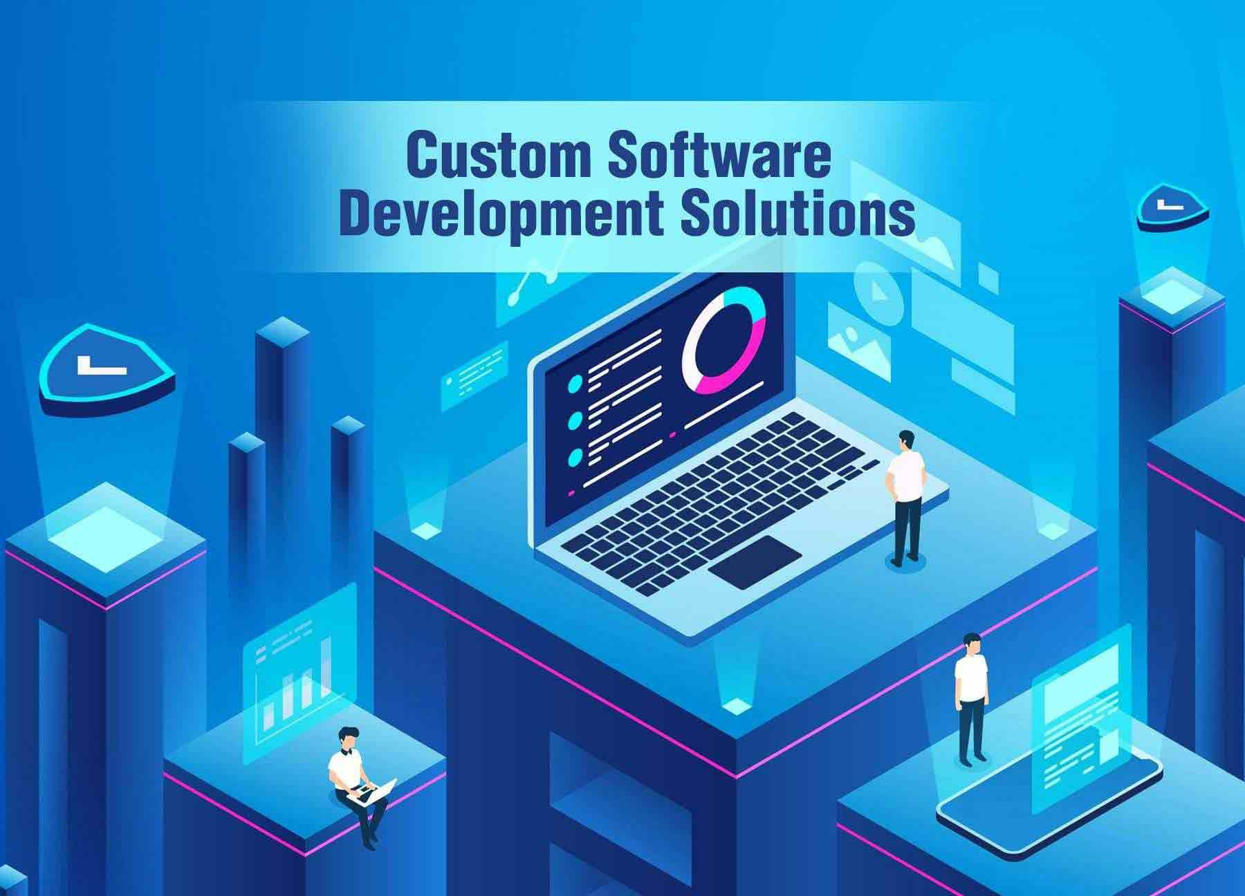

**Fig 2.1**: Software Development

#### 2.1.1 SOFTWARE DEVELOPMENT

Our software development services aim to deliver tailored solutions that align with customer objectives and drive measurable results. We cover the entire software development process, ensuring a cohesive journey from ideation to deployment and beyond.

* **End-to-End Development Process**: Comprehensive management of all phases, from initial planning to post-deployment support, guaranteeing robust and reliable outcomes.
* **Business-Centric Customization**: Solutions crafted to meet specific operational needs and enhance the overall user experience.
* **Advanced Tools and Practices**: Utilizing state-of-the-art technologies and agile methodologies to create scalable and future-ready software.



**Fig 2.2**: Test Automation

#### 2.1.2 TEST SERVICES

Our testing services are designed to ensure the highest standards of quality and performance for your applications. By focusing on meticulous evaluation and thorough validation, we deliver software that meets customer expectations.

* **Comprehensive Quality Assurance**: Rigorous manual testing processes to identify and resolve issues at every stage of development.
* **User-Centric Approach**: Ensuring the application is intuitive, functional, and reliable for end-users.
* **Early Defect Detection**: Proactive testing to catch and address potential issues during the development cycle, reducing rework and improving release efficiency.



**Fig 2.3**: OUR PRODUCTS

#### 2.1.3 [OUR](https://www.devtown.in/product/cyber-security-mentored-live-classes) PRODUCTS

We offer proprietary software solutions designed to address specific business needs, enhancing productivity and simplifying operations for our clients.

* **Camrilla**: A business management application specifically designed for photographers. Camrilla helps users manage leads, track assignments and events, handle payment workflows, and monitor payment statuses, offering a complete solution for running a photography business.
* **Appointify**: An intuitive application built for consultants and their clients to manage meetings effectively. Appointify enables scheduling, organization, and management of meetings, helping users streamline their business processes and drive growth..

# CHAPTER 3 INTRODUCTION TO WORK

**ASSIGNED**

## 3.1 INTRODUCTION TO ASSIGNED WORK

## 3.1.1 Feature Enhancement and User Feedback Implementation

## OBJECTIVE: To incorporate new features into the Camrilla web version based on initial user feedback, focusing on user-centric improvements.

## TASKS ASSIGNED:

## ****Feedback Analysis**:** Collect and analyze user feedback from the Camrilla mobile app and initial web version tests.

## ****Feature Development**:** Add new features such as advanced photo categorization, customizable templates, and improved client communication tools.

## ****UI Enhancements**:** Make design adjustments to improve the usability of critical features like bookings and payment tracking.

## ****Performance Optimization**:** Optimize web application loading times and ensure smooth transitions between pages.

## ****Cross-Browser Testing**:** Conduct compatibility tests across popular browsers like Chrome, Firefox, and Safari.

## ****Team Collaboration**:** Work with the mobile app team to ensure seamless integration of shared features and data synchronization.

## 

## 3.1.2 Cloud Computing and Web Development

## 

## OBJECTIVE: To enhance skills in cloud computing and full-stack web development by working on AWS services, real-time communication tools, and creating responsive websites for various industries..

## TASKS ASSIGNED:

## Learned foundational AWS services such as EC2, Lambda, and S3 to build scalable and cost-effective cloud solutions.

## Explored serverless computing concepts and integrated AWS services for practical applications.

## Developed the HIMTEK website, emphasizing Smart Water Management and sustainability through advanced features and a responsive design.

## Designed and built the Fanizm website from scratch, focusing on user-friendly, responsive design and performance optimization.

## 3.1.3 Software Planning and Competitor Analysis

## 

## OBJECTIVE: Plan and design a scheduling software for consultants, focusing on unique features and competitive differentiation.

## TASKS ASSIGNED:

## Conducted a brainstorming session to outline the project goals and milestones.

## Performed an in-depth competitor analysis, reviewing products like Calendly to understand their core offerings.

## Identified gaps and opportunities to include innovative features that would give our software a competitive edge.

## Created a feature map to visualize the flow of user interactions and feature implementation priorities.

## 3.1.4 VKBS Code Refinement

## 

## OBJECTIVE: Enhance the codebase of the VKBS project by resolving bugs and improving overall performance.

## TASKS ASSIGNED:

## Conducted a thorough code review to identify performance bottlenecks and bugs.

## Fixed existing bugs to ensure smooth functionality and eliminate critical errors.

## Optimized database queries to improve load times and efficiency.

## Integrated branch-specific changes into the master branch using Git, maintaining proper version control.

## Resolved merge conflicts during integration, ensuring code quality and functionality were not compromised.

## 3.1.5 Taciti Deployment and Optimization

## 

## OBJECTIVE: Deploy and optimize the Taciti project for a cloud-based environment using Microsoft Azure.

## TASKS ASSIGNED:

## Set up the Taciti project on Microsoft Azure, enabling cloud-hosted accessibility for users.

## Configured Azure services like App Service and Storage for efficient hosting and scalability.

## Tested the project on Azure to validate functionality and resolve deployment-specific issues.

## Worked on creating a production-ready build for Taciti to ensure optimal performance on Azure.

## Documented deployment processes and best practices for future reference and scalability.

## 3.1.6 LMS Implementation for Medical Education

## 

## OBJECTIVE: Implement and customize an LMS tailored to the needs of Atal Bihari Vajpayee Medical College, ensuring alignment with the MBBS curriculum and departmental requirements.

## TASKS ASSIGNED:

## Presented a demo of the LMS to the Head of the Biochemistry Department, showcasing its core functionalities.

## Collected feedback from the Biochemistry team to refine and enhance LMS features.

## Studied the MBBS course structure, semester patterns, and educational workflows in collaboration with medical faculty.

## Gathered and mapped departmental syllabi as per the National Medical Commission (NMC) guidelines for integration into the LMS.

## Set up the Biochemistry department in the LMS, assigned roles, and created test accounts for initial functionality testing.

## Conducted system tests to verify usability, ensuring the LMS met the specific needs of medical education.

## 

## 3.2 MONTHLY OVERVIEW OF INTERNSHIP ACTIVITIES

### First Month (June 2024)

Focused on incorporating new features into the Camrilla web version based on user feedback. Key achievements included developing advanced photo categorization, customizable templates, and improved client communication tools. Significant progress was made in UI/UX enhancements, performance optimization, and cross-browser compatibility testing. Collaborated effectively with the mobile app team to ensure seamless integration and synchronization of shared features.

### Second Month (July 2024)

Gained foundational knowledge in AWS services, including EC2, Lambda, and S3, and explored serverless computing for scalable solutions. Successfully developed two responsive websites: the HIMTEK website, highlighting Smart Water Management, and the Fanizm website, emphasizing user-friendly design and performance. These tasks reinforced cloud computing concepts and full-stack development skills, showcasing practical applications in real-world projects.

### Third Month (August 2024)

Initiated the planning phase for scheduling software targeted at consultants, focusing on unique features to stand out in a competitive market. Conducted detailed competitor analysis, identifying gaps and opportunities. Designed a comprehensive feature map to outline user interactions and prioritize feature development. This phase laid a strong foundation for building innovative, user-centric scheduling software.

### Fourth Month (September 2024)

Undertook an in-depth review of the VKBS codebase to resolve performance bottlenecks and critical bugs. Optimized database queries for faster load times and merged branch-specific changes into the master branch using Git. Successfully resolved merge conflicts, ensuring a robust, streamlined codebase ready for production.

### Fifth Month (October 2024)

Deployed the Taciti project on Microsoft Azure, configuring services such as App Service and Storage for optimal performance. Created a production-ready build, conducted thorough testing, and resolved deployment-specific issues. Documented the deployment process, ensuring scalability and ease of future updates.

### Sixth Month (November 2024)

Customized and implemented an LMS for Atal Bihari Vajpayee Medical College, aligning it with MBBS curriculum requirements. Mapped departmental syllabi as per NMC guidelines and set up the Biochemistry department in the LMS. Successfully conducted a demo, gathered feedback, and tested system functionalities to ensure usability for faculty and students.

**Summary**

Over the past six months, I have contributed significantly to various projects and tasks, showcasing my versatility and technical expertise. I enhanced the Camrilla web version by incorporating user feedback, adding advanced features, and optimizing performance while collaborating with the mobile app team for seamless integration. My cloud computing skills evolved as I gained proficiency in AWS services like EC2, Lambda, and S3, applied serverless computing concepts, and developed responsive websites such as HIMTEK and Fanizm. I led the planning and competitor analysis for innovative scheduling software, identifying unique features and designing user interaction flows to create a competitive edge. My efforts in code refinement for the VKBS project resolved critical bugs, improved performance, and ensured clean integrations through efficient version control. For the Taciti project, I managed cloud deployment on Microsoft Azure, creating production-ready builds and documenting scalable processes. Additionally, I spearheaded the LMS implementation for Atal Bihari Vajpayee Medical College, aligning it with MBBS curriculum standards, mapping syllabi, and ensuring functionality through rigorous testing. These endeavors reflect a blend of technical development, strategic planning, and user-focused enhancements, contributing to impactful solutions across diverse domains.

# CHAPTER 4

**DETAILED STUDY**

## 4.1 Overview

Over the past six months, I have been deeply involved in several impactful projects, which have allowed me to develop and refine my technical and strategic skills across various domains. My journey began with enhancing the Camrilla web version, where I focused on incorporating user feedback to add advanced features like photo categorization, customizable templates, and improved communication tools. This task not only involved feature development but also required close collaboration with the mobile app team to ensure seamless integration across platforms, as well as performance optimization and cross-browser testing to ensure a consistent user experience. Concurrently, I gained hands-on experience in cloud computing by exploring AWS services such as EC2, Lambda, and S3. This knowledge was applied in real-world projects like the HIMTEK website, focusing on Smart Water Management, and the Fanizm website, which emphasized performance optimization and responsive design. Through these projects, I was able to leverage serverless computing to create scalable, efficient, and cost-effective solutions. In parallel, I initiated the design and planning for a scheduling software tailored for consultants, conducting extensive competitor analysis to identify gaps and unique features that would differentiate our product in the market. The development of this software aimed to address the specific needs of consultants, such as customizable workflows, integration with calendar apps, and AI-powered scheduling assistance. Furthermore, I contributed to the VKBS project by refining its codebase, resolving bugs, optimizing database queries, and ensuring smooth integrations through version control practices. I also played a critical role in deploying the Taciti project to Microsoft Azure, where I managed the cloud hosting setup, optimized performance, and ensured scalability. Lastly, I worked on implementing a Learning Management System (LMS) for Atal Bihari Vajpayee Medical College, ensuring the system was tailored to the MBBS curriculum and aligned with the National Medical Commission (NMC) guidelines. This project required careful mapping of departmental syllabi, customization for medical education workflows, and extensive testing to ensure functionality and usability. Across all these projects, I gained valuable experience in cloud computing, web development, software design, and project management, working toward creating scalable, user-centric, and efficient solutions that addressed real-world challenges and improved user experiences.

### 4.2 Expected Outcome

The expected outcomes from these projects were focused on delivering practical, user-centric solutions that addressed specific needs and improved overall performance:

* **Camrilla Web Version Enhancements**:

Improve user engagement by adding features like advanced photo categorization, customizable templates, and enhanced communication tools. Streamline workflows and increase user satisfaction through a more organized, responsive platform. Ensure seamless integration with the mobile app, providing a consistent user experience across both platforms.

* **Cloud Computing & Full-Stack Development**:

Develop scalable, responsive websites using AWS services, such as HIMTEK and Fanizm. Ensure fast, efficient, and user-friendly platforms that handle growth while providing excellent user experiences across devices. Leverage cloud technologies for cost-effective, scalable solutions with easy maintenance.

* **Scheduling Software for Consultants**:

Create a unique scheduling tool with AI-powered features and customizable workflows. Streamline scheduling processes, reduce conflicts, and save time for consultants. Develop a product that stands out in the competitive market through innovative features

* **VKBS Code Refinement**:

Deliver a high-performance, bug-free system by optimizing database queries and resolving critical issues. Improve load times and system stability to ensure readiness for production and reliable functionality.

* **Taciti Deployment on Microsoft Azure:**

Successfully deploy the application to Microsoft Azure, ensuring scalability and optimal performance. Provide a seamless and reliable cloud solution capable of handling high-traffic periods without issues.

* LMS Implementation for Atal Bihari Vajpayee Medical College:

Implement a tailored learning management system aligned with the MBBS curriculum and NMC guidelines. Enhance the learning experience for faculty and students, streamline administrative workflows, and improve educational outcomes.

Overall, the projects aimed to achieve technical excellence, improve user experiences, and deliver scalable, efficient solutions that positively impacted both users and organizations.

### 4.3 Feedback Analysis and Feature Development for Camrilla Web Version

This task focused on enhancing the Camrilla web version by analyzing initial user feedback from the mobile app and web platform. The goal was to identify pain points and user needs, allowing for the development of key features that would improve the user experience. The process started with collecting feedback through surveys, user interviews, and usage analytics, which revealed common challenges in photo management, communication, and navigation. Based on this, several new features were proposed, such as advanced photo categorization, customizable templates, and improved client communication tools. Additionally, design adjustments were made to critical functions like booking systems and payment tracking, improving both functionality and ease of use.

* **User-Centric Enhancements:** A strong focus was placed on creating a more intuitive user interface to simplify navigation and enhance engagement.
* **Advanced Photo Categorization:** This feature allowed users to categorize and filter their photos based on tags, events, or themes, making it easier to search and organize visual content.
* **Customizable Templates:** Users could now personalize templates for their portfolios or presentations, offering more flexibility in showcasing their work.
* **Client Communication Tools:** Integration of features like messaging, appointment scheduling, and automated reminders helped improve client relationships and streamline communication.
* **UI/UX Improvements:** Streamlined design elements were implemented to make essential functions, such as bookings and payments, more accessible and responsive.
* **Cross-Browser Testing:** Ensured that the application worked consistently across multiple browsers (Chrome, Firefox, Safari), improving accessibility for a wider audience.

The key to success in this project was maintaining close collaboration with the mobile app team to ensure that the features and functionalities integrated seamlessly across both platforms. Ultimately, these improvements contributed to a polished, user-friendly web application that provided a unified, high-performance experience for users.

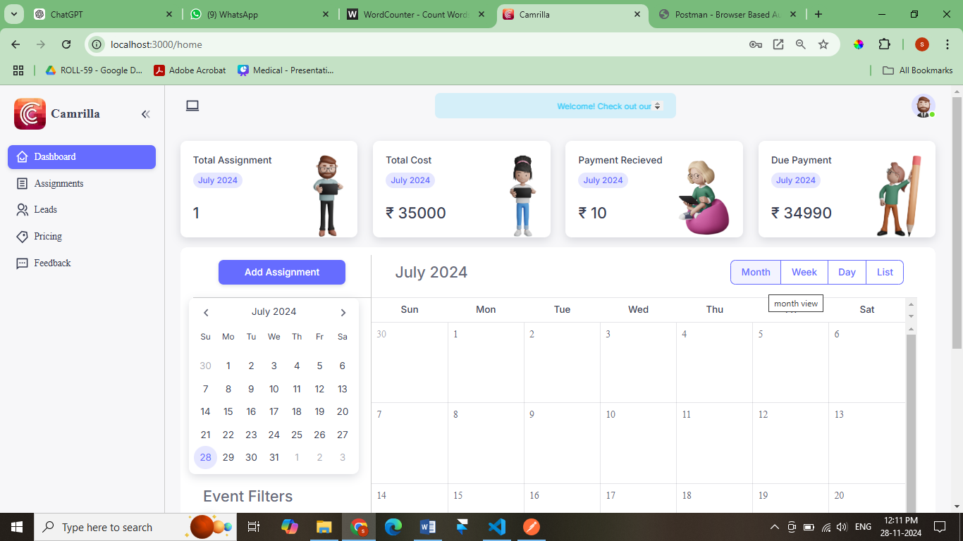 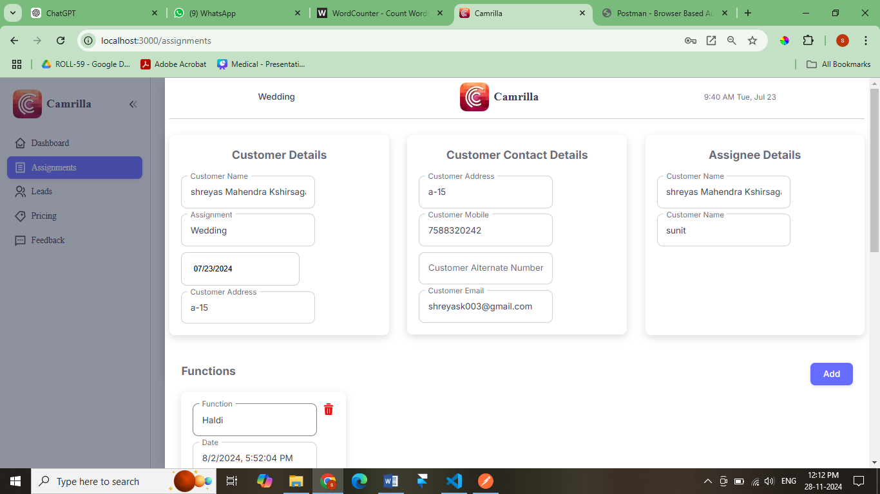

### 4.4 Cloud Computing and Full-Stack Development

This task focused on building technical proficiency in cloud computing and full-stack web development by applying AWS services in real-world projects. The primary objective was to design scalable and cost-efficient solutions using services like EC2 (for hosting), Lambda (for serverless computing), and S3 (for data storage). The task included developing two fully functional websites: HIMTEK, which highlighted Smart Water Management solutions, and Fanizm, a responsive website designed with a focus on performance and user experience. The project emphasized integrating cloud-based tools and frameworks to create optimized web applications that are reliable, scalable, and secure.

* **AWS Integration:** By utilizing EC2 instances, AWS Lambda functions, and S3 storage, the project demonstrated the flexibility and scalability of cloud-based applications. EC2 instances were used to host web applications, while Lambda functions provided serverless capabilities to run code without provisioning servers, ensuring cost-efficiency.
* **Serverless Computing:** Serverless computing was a key concept explored in this project, with AWS Lambda allowing for event-driven architecture. This approach reduced the need for managing infrastructure, enabling faster development cycles and lower costs.
* **HIMTEK Website:** This website, focused on Smart Water Management and sustainability, was developed to showcase the potential of cloud computing in solving real-world environmental challenges. The platform provided interactive features and a responsive layout, emphasizing data-driven solutions for sustainability.
* **Fanizm Website:** Fanizm was built with a mobile-first design, ensuring that the website was fast, responsive, and optimized for all devices. The project included performance optimization techniques to ensure quick load times and smooth transitions.
* **Cloud Optimization:** Using cloud services for hosting, storage, and computation allowed for scalable solutions that could grow with user demand while maintaining high performance. S3 was utilized for secure file storage, and Lambda ensured that data processing tasks were efficient and reliable.

The expected outcome of this project was to not only gain hands-on experience with cloud computing technologies but also create web applications that addressed industry-specific needs. By developing these websites, I was able to apply theoretical concepts to real-world challenges, reinforcing both cloud development skills and web development techniques.

### 4.5 Scheduling Software Planning and Competitor Analysis

The goal of this project was to plan and design an innovative scheduling software targeted at consultants, focusing on unique features and competitive differentiation. The first phase involved conducting an extensive competitor analysis to understand the strengths and weaknesses of existing tools like Calendly. The analysis revealed gaps in the market, particularly in features that catered to consultants’ specific needs, such as customizable scheduling workflows, AI-driven time recommendations, and integration with third-party applications like Google Calendar and Outlook. The insights gathered from this process informed the development of a feature map, which outlined the core functionalities, user interface design, and workflows.

* **Competitor Research:** A deep dive into existing scheduling tools like Calendly provided valuable insights into the most requested features by users, as well as areas for improvement. Features like automated time zone detection, integration with calendar apps, and group scheduling were explored.
* **Feature Differentiation:** The software was designed with unique features to differentiate it from competitors, such as an AI-powered scheduling assistant that helps consultants find optimal time slots based on their preferences and availability.
* **User Interaction Design:** The development of an intuitive user interaction flow was key. This included a straightforward booking process with real-time updates, notifications, and reminders that would simplify the scheduling process for consultants and their clients.
* **Customization and Flexibility:** One of the main goals was to allow users to personalize their scheduling experience. Customizable time slots, calendar integrations, and automated reminders were prioritized to ensure that the software could be tailored to individual preferences.
* **Target Audience:** Understanding the challenges faced by consultants, the software aimed to offer features that reduce scheduling conflicts, optimize work hours, and automate routine tasks, making the process more efficient.

The expected outcome of this project was to create a scheduling software that addresses the unique needs of consultants while offering a more efficient and flexible alternative to existing tools. By focusing on user-centric design and integrating innovative features, the software aimed to provide tangible benefits in terms of productivity and convenience.

**4.6 Workflow diagram**

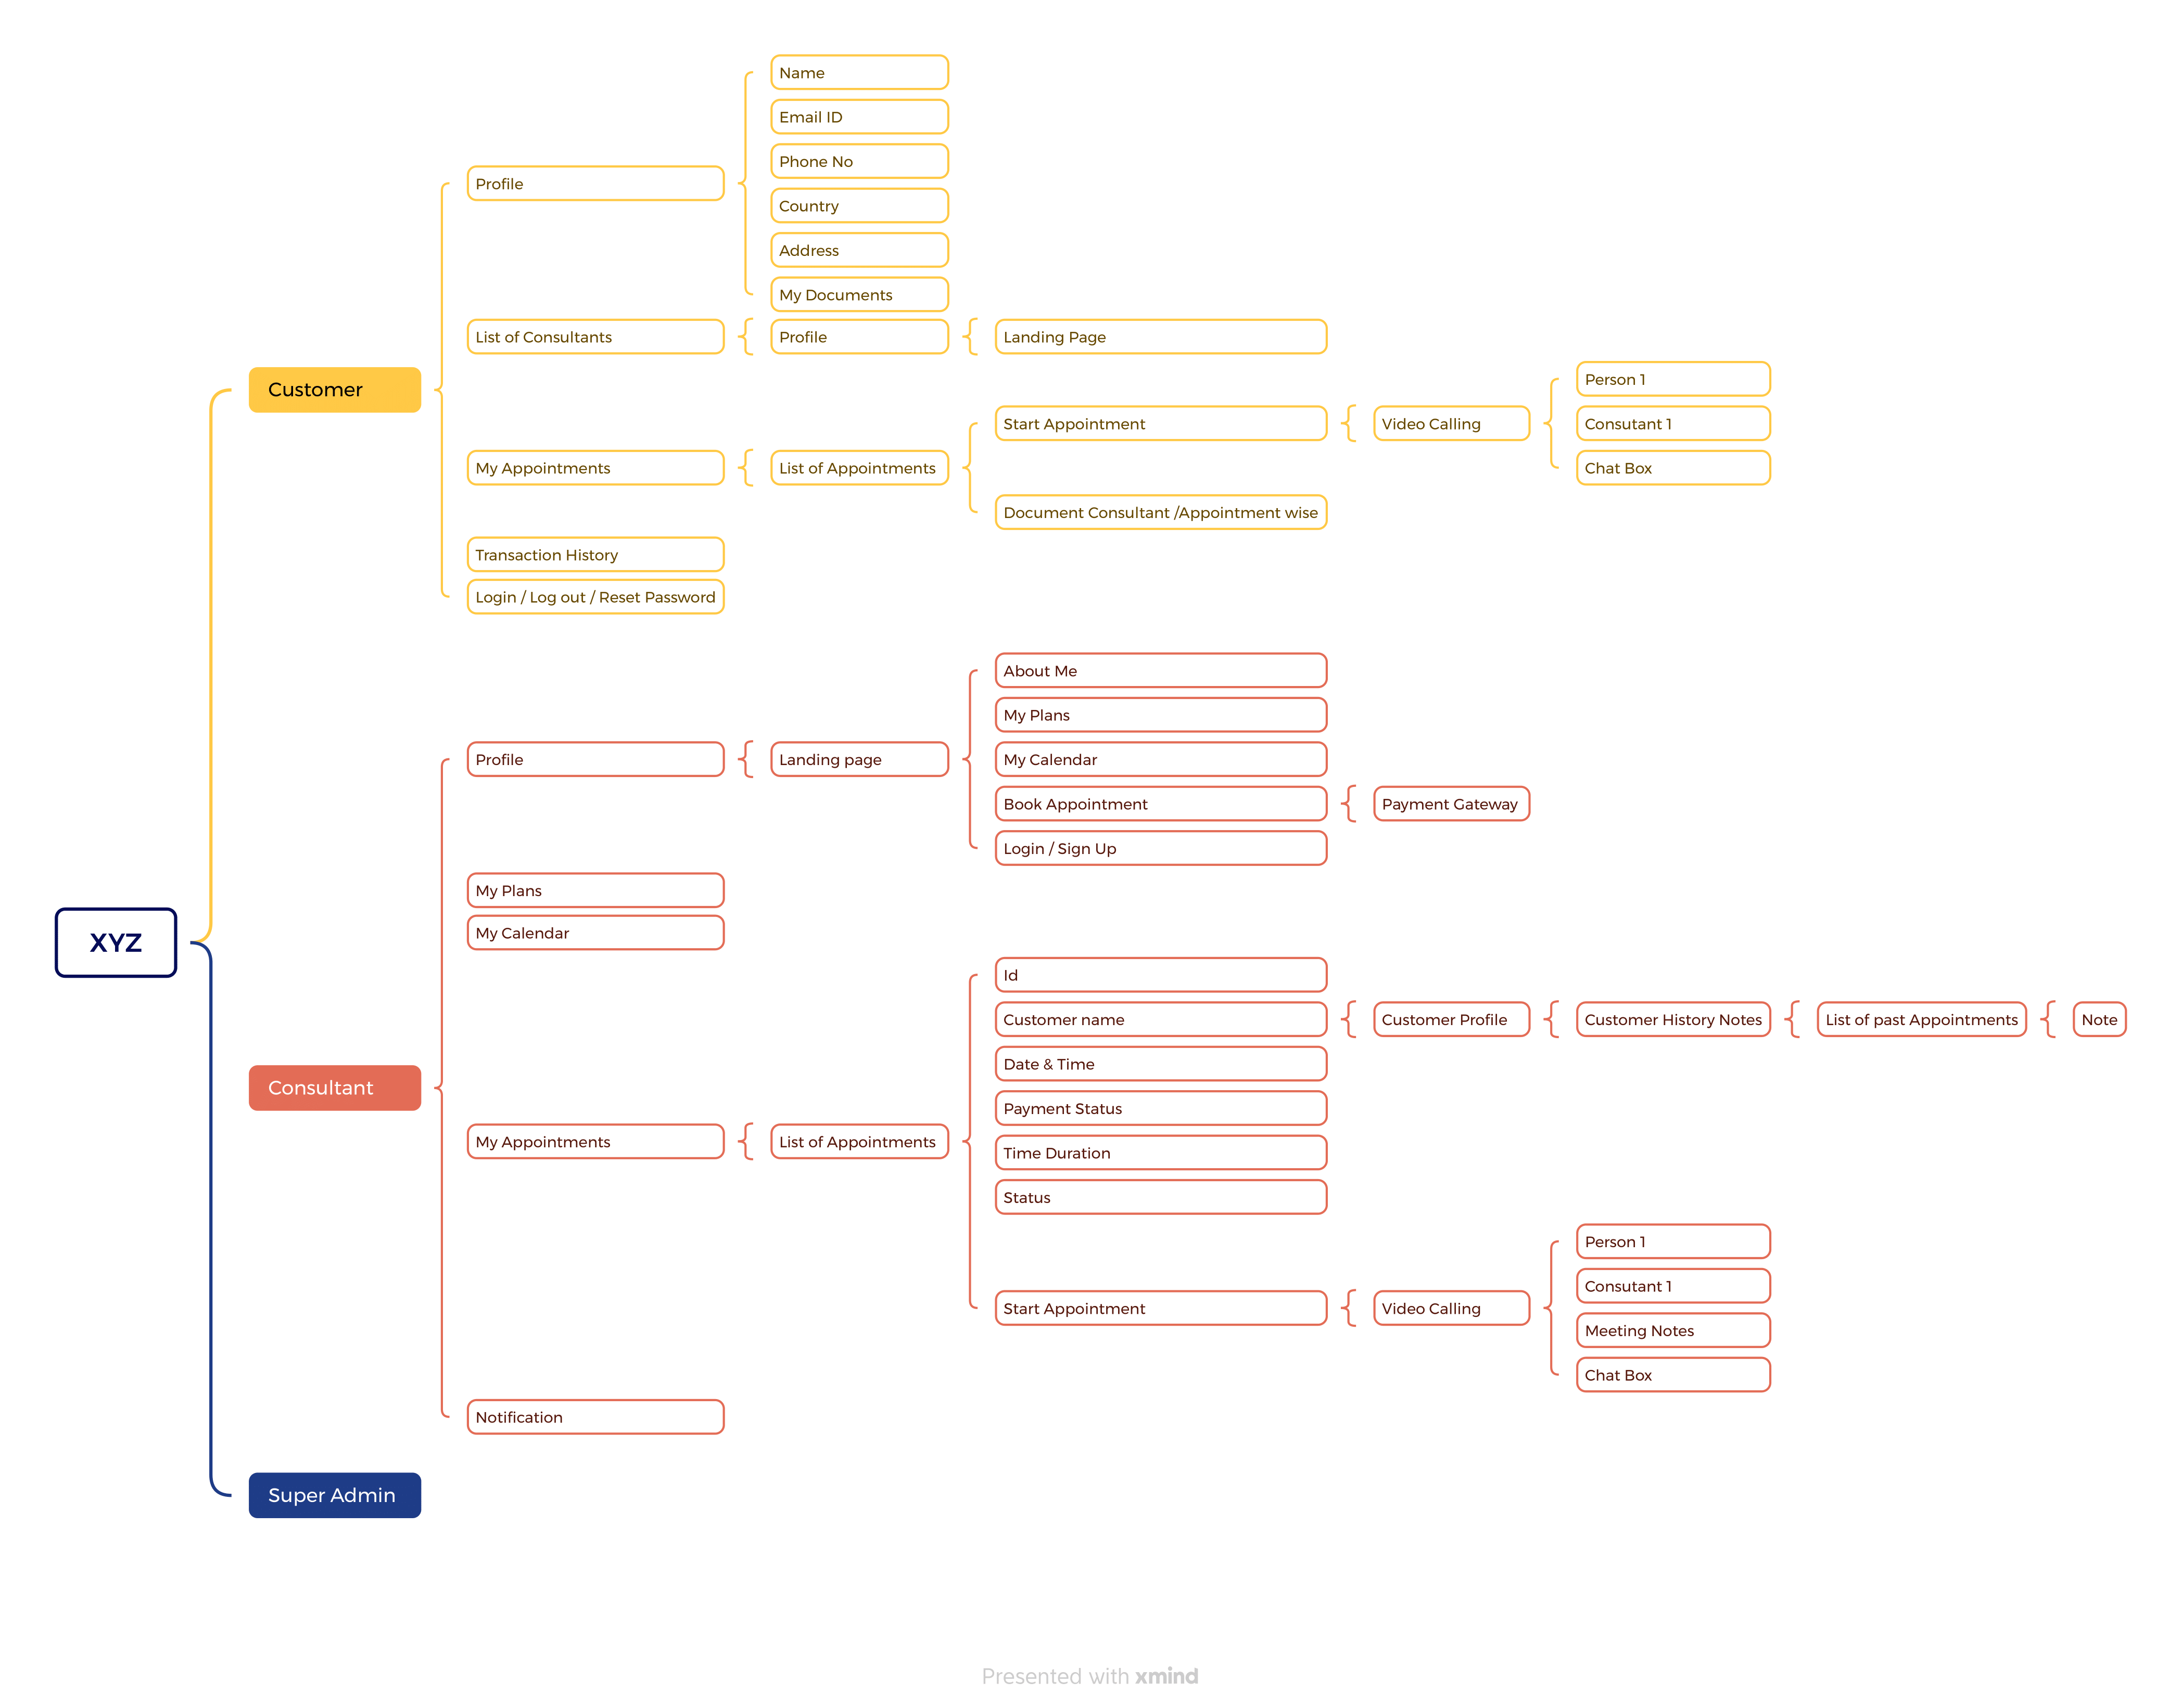

### 4.7 VKBS Code Refinement

The VKBS project focused on improving the codebase of an existing application by addressing performance issues, fixing bugs, and optimizing database queries. The goal was to ensure that the application ran efficiently, with minimal latency and error-free functionality. The process began with a thorough code review to identify bottlenecks, followed by bug fixes that addressed critical errors impacting the user experience. Additionally, database queries were optimized to improve load times and overall application performance. Once the issues were resolved, the next step was integrating branch-specific changes into the master branch, maintaining proper version control and resolving merge conflicts.

* **Code Review and Bug Fixing:** A comprehensive review of the existing code was conducted to identify areas that could be improved. Bugs that caused crashes or inconsistencies in the application were resolved, ensuring a smoother user experience.
* **Database Query Optimization:** A significant part of the code refinement was focused on optimizing database queries. By reducing the number of queries and optimizing their execution, load times were drastically reduced, making the application faster and more efficient.
* **Merge Conflict Resolution:** During the integration of branch-specific updates, it was crucial to maintain version control and ensure that new changes did not break existing functionality. Merge conflicts were handled carefully to ensure code integrity.
* **Performance Optimization:** Performance testing was conducted throughout the process to identify and address any remaining bottlenecks. The goal was to ensure that the application could scale effectively and handle larger user bases without performance degradation.
* **Version Control with Git:** All changes were made using Git, which allowed for efficient collaboration and ensured that the master branch always contained the most up-to-date and stable version of the code.

The outcome of this task was a refined, optimized codebase that was ready for deployment. This not only improved the functionality of the VKBS application but also ensured that it could scale and perform efficiently in real-world use.

**Screens :**

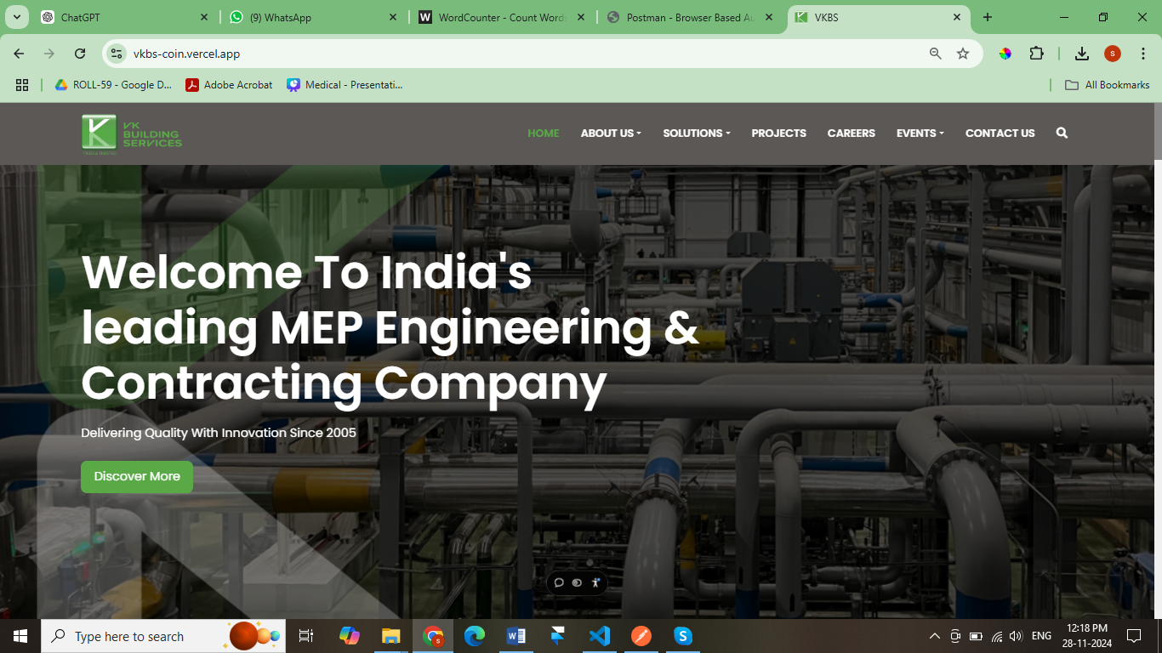

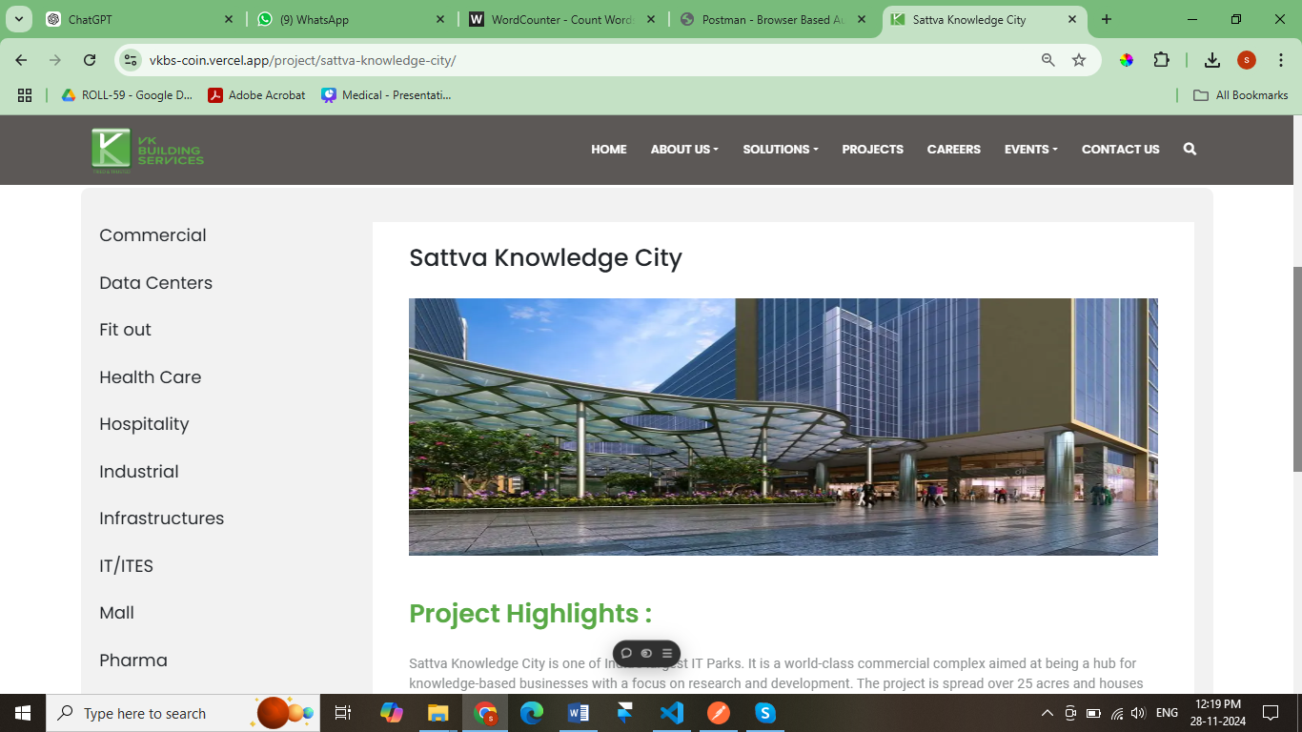

### 

### 4.8 Taciti Deployment and Optimization

This task was focused on deploying the Taciti project to Microsoft Azure, optimizing it for cloud hosting and ensuring scalability. The deployment process included configuring Azure App Services for hosting and Azure Storage for efficient data management. The project required careful testing to ensure that the application was fully functional in the cloud environment, resolving any issues that arose during deployment. Additionally, performance optimizations were implemented to ensure that the application performed well under varying levels of load. The final step involved documenting the deployment process and best practices to make future updates and scalability easier.

* **Azure Deployment:** The Taciti project was deployed on Microsoft Azure, utilizing Azure App Services for hosting and Azure Storage for managing data efficiently. This cloud-based approach allowed for scalability and reliability.
* **Testing and Optimization:** After the initial deployment, the project was tested thoroughly to identify deployment-specific issues, such as connectivity or performance problems. Performance optimization ensured the application could handle traffic spikes without compromising speed or functionality.
* **Production-Ready Build:** A production-ready build of the application was created, ensuring that all features were fully functional and optimized for live use. This included ensuring that all configurations were set up correctly for the cloud environment.
* **Documentation:** Detailed documentation was created for the deployment process, which included step-by-step instructions on how to deploy the application, as well as best practices for maintaining and scaling the system.
* **Scalability and Future Growth:** The deployment was designed to ensure that the system could scale easily as the user base grew, with the ability to handle increased data and user traffic.

The goal of this project was to ensure that Taciti was fully optimized for the cloud, with reliable hosting and scalable performance. By deploying the application on Azure, the project was able to take full advantage of cloud technology, ensuring a robust and future-proof solution.

**Screens** :

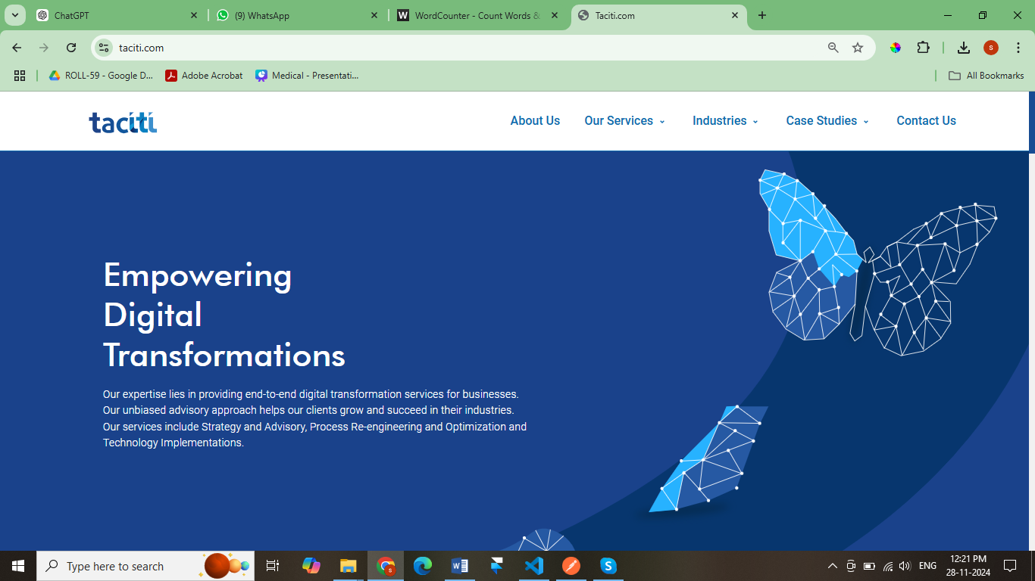

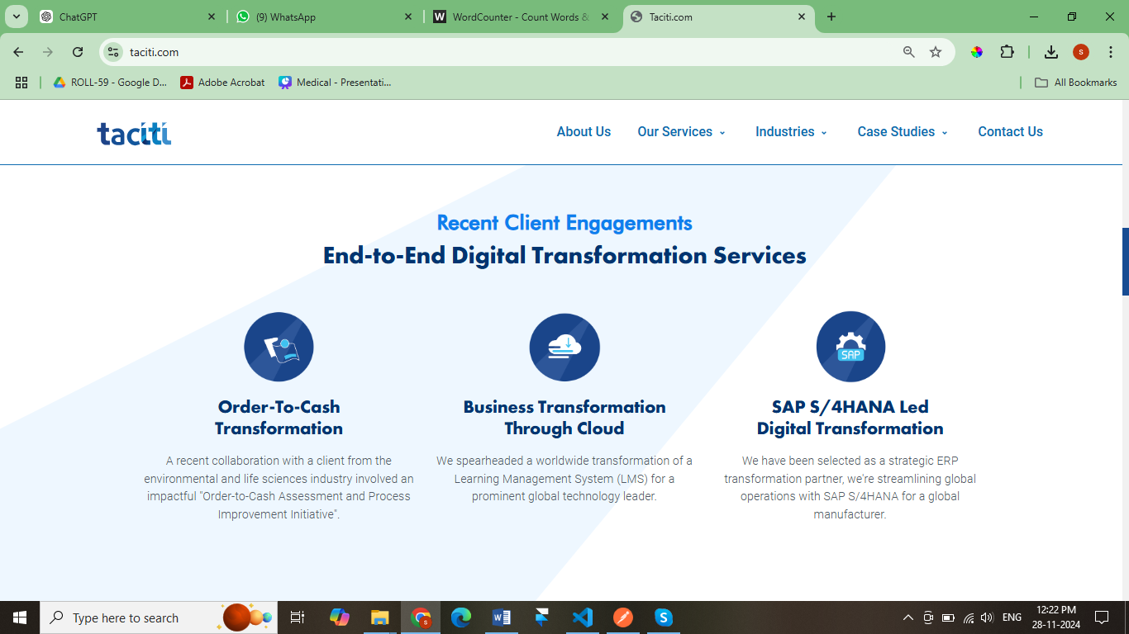

### 

### 4.9 LMS Implementation for Medical Education

The implementation of the Learning Management System (LMS) for Atal Bihari Vajpayee Medical College was tailored to meet the specific needs of the MBBS curriculum. The project involved mapping departmental syllabi in accordance with National Medical Commission (NMC) guidelines and setting up the system to support medical education workflows. The first phase of the project involved presenting a demo of the LMS to the Biochemistry department to gather feedback, which helped refine the system’s functionalities. Roles were assigned to faculty and students, and test accounts were created for initial functionality testing. The LMS was then customized to align with medical education’s specific needs, including support for medical terms, quizzes, assignments, and tracking student progress.

* **Mapping the MBBS Curriculum:** The LMS was customized to reflect the MBBS course structure, which involved mapping syllabi for each department in line with NMC guidelines. This ensured that the LMS could support the academic and practical needs of medical students and faculty.
* **Departmental Setup:** The Biochemistry department was set up within the LMS, complete with user roles for faculty and students. Test accounts were created to simulate real-world usage and ensure that the system worked as intended.
* **Feedback and Refinement:** A demo of the LMS was presented to the Biochemistry department to collect feedback and refine the system’s features. This ensured that the LMS was intuitive and aligned with the needs of medical faculty.
* **Medical-Specific Features:** The system was designed to support medical education with features like the ability to track student progress, assign quizzes, and facilitate online learning. Special consideration was given to terminology and assessments specific to medical studies.
* **Testing and Validation:** Thorough testing was conducted to verify that the LMS was fully functional and met the requirements of faculty and students. Feedback from the testing phase was incorporated to further refine the system.

The expected outcome of this task was to implement a fully functional and customized LMS that could support medical education effectively, offering faculty and students an intuitive platform to manage coursework, track progress, and enhance learning.

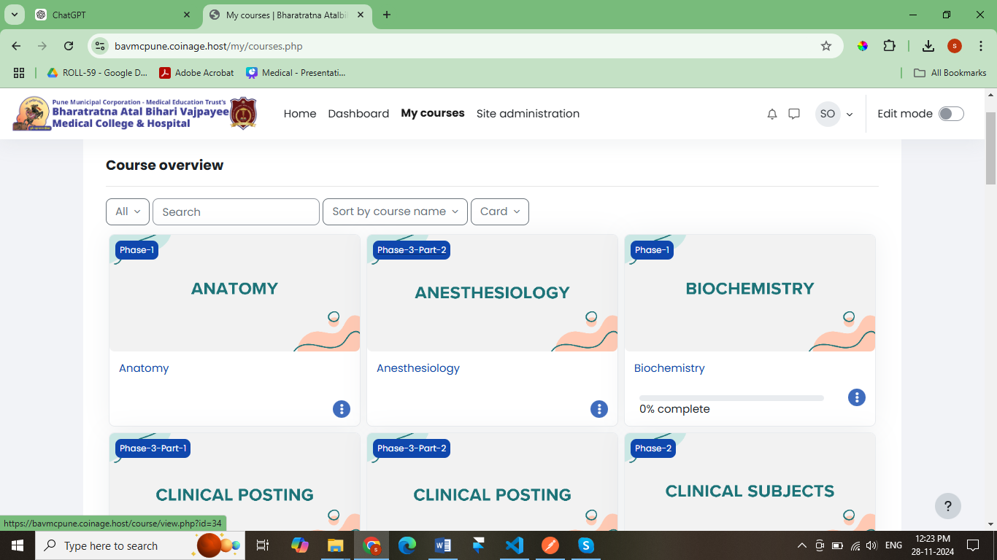

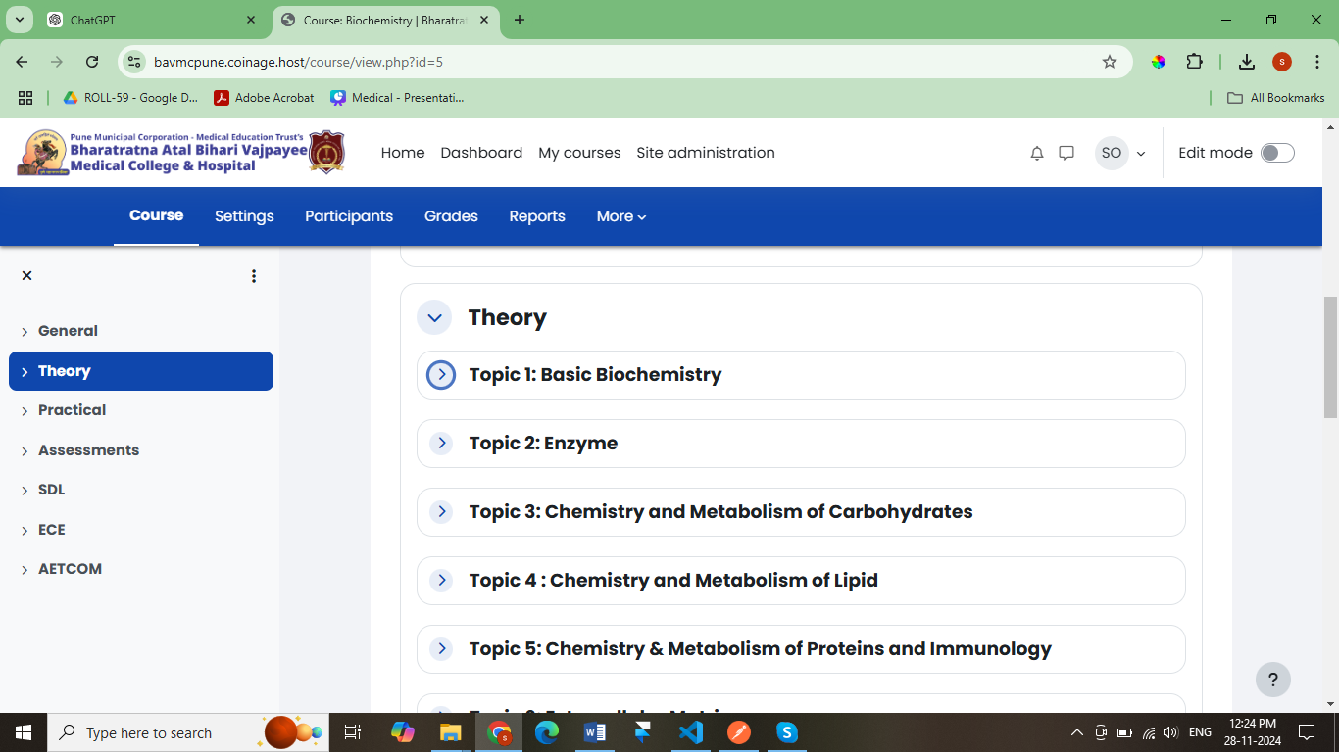

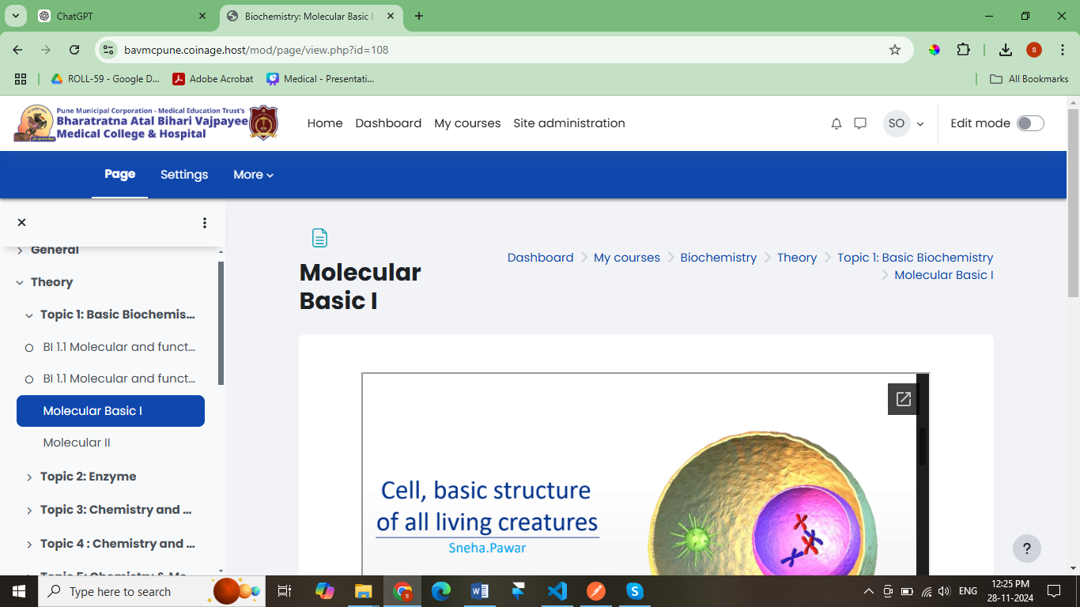

# CHAPTER 5

**OUTCOMES (Case Study)**

### ****5.1 Feedback Analysis and Feature Development for Camrilla Web Version****

**Overview:**  
This task involves collecting and analyzing user feedback from the Camrilla mobile app and initial web version tests to implement enhancements that focus on user-centric improvements.

**Importance:**

* Improves user satisfaction and engagement by directly addressing pain points.
* Enhances user retention by ensuring the platform meets evolving needs.
* Establishes a feedback-driven development approach for continual improvement.

**Expected Outcome:**

* A web platform optimized with new features such as advanced photo categorization, customizable templates, and improved client communication tools.
* Enhanced usability and performance for critical functions like bookings and payment tracking.

**Brief Description of Features and Functionalities:**

* **Advanced Photo Categorization:** Organize photos by tags, events, or themes for easy navigation.
* **Customizable Templates:** Allow users to personalize templates for unique client presentations.
* **Client Communication Tools:** Streamlined messaging, appointment scheduling, and follow-ups.
* **UI/UX Enhancements:** Intuitive layouts, faster load times, and seamless transitions between pages.
* **Cross-Browser Compatibility:** Ensures consistent functionality across major browsers like Chrome, Firefox, and Safari.

**Project Goals:**  
Deliver a user-centric, high-performing web platform that integrates seamlessly with the mobile app, ensuring a cohesive user experience.

### ****5.2 Cloud Computing and Full-Stack Development****

**Overview:**  
This task focuses on enhancing cloud computing skills and developing responsive websites for diverse industries using AWS services and serverless computing concepts.

**Importance:**

* Enables scalable, secure, and cost-effective cloud solutions.
* Promotes efficiency through serverless computing and responsive web designs.
* Addresses the growing demand for cloud-based infrastructure.

**Expected Outcome:**

* Proficiency in AWS services like EC2, Lambda, and S3 for real-world applications.
* Completion of responsive websites (HIMTEK and Fanizm) showcasing advanced features and sustainability concepts.

**Brief Description of Features and Functionalities:**

* **AWS Integration:** Utilized EC2 for scalable hosting, S3 for storage, and Lambda for event-driven processes.
* **Responsive Websites:**
  + HIMTEK: Features Smart Water Management solutions and sustainability principles.
  + Fanizm: User-friendly interface emphasizing speed and aesthetic appeal.

**Project Goals**   
Build a foundation in cloud computing while delivering functional, industry-specific web solutions.

### ****5.3 Scheduling Software Planning and Competitor Analysis****

**Overview:**  
This phase focused on planning a unique scheduling software tailored for consultants, emphasizing competitive differentiation through innovative features.

**Importance:**

* Addresses a niche market with a growing demand for efficient scheduling tools.
* Ensures the product stands out with user-focused design and advanced functionalities.

**Expected Outcome:**

* A roadmap for development with clearly identified gaps and unique features.
* A comprehensive feature map guiding the implementation process.

**Brief Description of Features and Functionalities:**

* **Advanced Scheduling Algorithms:** AI-based recommendations for time optimization.
* **Integration Options:** Compatibility with calendar apps like Google Calendar and Outlook.
* **User Interaction Flow:** Simple booking workflows with notifications and reminders.

**Project Goals:**  
Create a scheduling tool that redefines convenience and productivity for consultants.

### ****5.4 VKBS Code Refinement****

**Overview:**  
This task involved resolving bugs and optimizing the performance of the VKBS codebase, ensuring a clean, efficient foundation for future updates.

**Importance:**

* Enhances application stability and responsiveness.
* Improves developer productivity by streamlining the codebase.
* Ensures smooth user experiences.

**Expected Outcome:**

* Elimination of critical bugs and performance bottlenecks.
* An optimized and well-documented codebase ready for future iterations.

**Brief Description of Features and Functionalities:**

* **Code Review and Bug Fixing:** Identified and resolved errors affecting functionality.
* **Database Optimization:** Improved query efficiency to reduce load times.
* **Version Control:** Ensured smooth branch integration and resolved merge conflicts.

**Project Goals:**  
Deliver a robust codebase that supports scalability and enhanced user performance.

### ****5.5 Taciti Deployment and Optimization****

**Overview:**  
This project involved deploying and optimizing Taciti on Microsoft Azure, focusing on performance and scalability.

**Importance:**

* Makes the project cloud-accessible, improving availability and reliability.
* Ensures cost-effectiveness and scalability for future growth.

**Expected Outcome:**

* A production-ready build optimized for Azure hosting.
* A documented process for efficient future deployments.

**Brief Description of Features and Functionalities:**

* **Azure Services Integration:** Configured App Service for hosting and Azure Storage for scalability.
* **Performance Testing:** Conducted thorough functionality checks to resolve deployment-specific issues.

**Project Goals:**  
Deploy a stable, scalable application while documenting best practices for long-term success.

### ****5.6 LMS Implementation for Medical Education****

**Overview:**  
The implementation of a Learning Management System (LMS) tailored to Atal Bihari Vajpayee Medical College’s curriculum, aligning with National Medical Commission (NMC) standards.

**Importance:**

* Improves the efficiency of medical education delivery.
* Ensures curriculum compliance with NMC guidelines.
* Facilitates a centralized platform for educators and students.

**Expected Outcome:**

* A functional LMS aligned with MBBS curriculum requirements.
* Faculty and students onboarded with a fully operational system for teaching and learning.

**Brief Description of Features and Functionalities:**

* **Curriculum Mapping:** Integrated semester-wise syllabus as per NMC guidelines.
* **Role Assignment:** Defined faculty and student roles with customizable permissions.
* **Testing and Feedback:** Conducted system testing to ensure ease of use and relevance.

**Project Goals:**  
Provide a user-friendly LMS that aligns with medical education standards and enhances learning outcomes.

# CHAPTER 6

**SCHEMATIC DIAGRAMS AND EXPLANATION**

**6.1 Appointify Application Work Flow Diagram**



## ****Customer****

The **Customer** section represents users who use the platform to connect with consultants. It contains the following components:

### ****Profile****

This section allows customers to manage their personal information:

* **Name**: The full name of the customer.
* **Email ID**: Email address for communication and notifications.
* **Phone No**: Contact number for communication.
* **Country**: The country of residence.
* **Address**: The customer's detailed address.
* **My Documents**: A section for customers to upload and manage personal or required documents.

### ****List of Consultants****

Here, customers can browse through a list of available consultants and their profiles:

* **Profile**: Displays the consultant’s details, services, and expertise.
* **Landing Page**: Acts as a homepage for the consultant, providing key information about their offerings.
* **Start Appointment**: A feature to begin an appointment with a chosen consultant.
* **Video Calling**: Enables real-time video communication with:
  + **Person 1**: Likely refers to individuals involved in the session (e.g., consultants or other participants).
  + **Consultant 1**: Refers to the specific consultant being contacted.
  + **Chat Box**: Offers a text-based communication option for additional interaction.

### ****My Appointments****

This feature helps customers manage their consultations:

* **List of Appointments**: Displays details of past, current, or future appointments.
* **Document Consultant/Appointment wise**: Allows access to documents or notes shared during specific appointments.

### ****Transaction History****

* Tracks payments made for services, including:
  + Details of past transactions.
  + Payment statuses (successful, pending, or failed).

### ****Login/Logout/Reset Password****

This is for account management, allowing customers to:

* Log in to access their account.
* Log out after their session.
* Reset passwords if they forget their credentials.

## ****2. Consultant****

The **Consultant** section represents professionals providing their services on the platform. Key components include:

### ****Profile****

* **Landing Page**: Displays a consultant's key information, including:
  + Expertise areas.
  + Offered plans or services.
  + Customer ratings or testimonials.

### ****My Plans****

* Represents a consultant’s service offerings, such as:
  + Pricing models.
  + Different consultation plans for customers.

### ****My Calendar****

* A scheduling tool that helps consultants manage:
  + Upcoming appointments.
  + Availability for new bookings.
  + Overlaps or potential scheduling conflicts.

### ****Book Appointment****

* A feature allowing consultants to book or approve appointments with customers.
* **Payment Gateway**: Integrated payment system to handle transactions.

### ****Login/Sign Up****

* Handles the account setup and login process for consultants.

### ****My Appointments****

This section helps consultants manage their appointments:

* **Id**: A unique identifier for each appointment.
* **Customer Name**: The name of the customer associated with the appointment.
* **Date & Time**: Scheduled time of the appointment.
* **Payment Status**: Tracks whether the payment has been completed.
* **Time Duration**: Duration of the scheduled session.
* **Status**: Current appointment status (e.g., scheduled, in progress, or completed).
* Additional tools:
  + **Customer Profile**: View details of the customer.
  + **Customer History Notes**: Review past notes or history associated with the customer.
  + **List of Past Appointments**: Shows all prior sessions with the customer.
  + **Note**: Consultants can add session-specific notes.
* Interaction options:
  + **Start Appointment**: Launch the session.
  + **Video Calling**: Real-time communication features, including:
    - **Person 1**: Individuals present in the session.
    - **Consultant 1**: The consultant leading the session.
    - **Meeting Notes**: Session-related notes for reference.
    - **Chat Box**: A text communication option.

## ****3. Super Admin****

The **Super Admin** section is designed for administrators managing the platform:

* **Notification**:
  + Sends system-wide notifications or updates.
  + Could include alerts for new user sign-ups, system maintenance, or updates to consultants/customers.

# CHAPTER 7

**PARTICIPATION OF EXTERNAL & INTERNAL GUIDE**

## In many internship programs, both internal and external guides or mentors play important roles in providing guidance, support, and supervision to the interns. Here's an overview of the participation of internal and external guides in an internship:

## 7.1 EXTERNAL GUIDE (SUPERVISOR):

## Assigned by the Organization:

## The external guide was typically assigned by the organization where the internship taken place. This individual was an experienced employee within the company.

## Responsibilities:

## Onboarding: Helps interns get acquainted with the organization's policies, procedures, and culture.

## Project Assignment: Assigns specific tasks or projects to the interns based on their learning objectives and the company's needs.

## Day-to-Day Supervision: Provides ongoing supervision, support, and feedback to ensure that interns are making progress and meeting their goals.

## Professional Development: Encourages skill development and provides opportunities for learning and growth.

## Performance Evaluation: Conducts periodic evaluations to assess the intern's performance and provide constructive feedback.

## Problem Solving: Assists interns in overcoming challenges and addressing issues within the organization.

## Benefits:

## Access to In-House Expertise: Interns benefit from the knowledge and expertise of experienced professionals within the organization.

## Integration: Internal guides help interns integrate into the workplace and become part of the team.

## Real-World Experience: They provide exposure to real-world business operations and challenges.

## 7.2 INTERNAL GUIDE (ACADEMIC ADVISOR):

## Assigned by the Educational Institution:

## The Internal guide is typically assigned by the intern's educational institution. Prof. Rupali Parte Mam is our faculty member.

## Responsibilities:

## Learning Objectives: Works with the intern to define learning objectives and ensure that the internship aligns with academic goals.

## Monitoring and Support: Maintains regular contact with the intern to monitor progress, provide academic support, and offer guidance.

## Academic Evaluation: Assesses the intern's academic performance during the internship and ensures that the experience conributes to the student's education.

## Feedback Loop: Facilitates communication between the organization and the educational institution to ensure that the internship meets academic requirements.

## Benefits:

## Academic Integration: Helps bridge the gap between academic learning and practical experience.

## Educational Alignment: Ensures that the internship is relevant to the intern's educational program and meets academic standards.

## Guidance and Mentorship: Offers additional mentorship and support beyond what the organization provides.

## The collaboration between internal and external guides ensures that the internship is a well-rounded educational experience. It allows interns to benefit from both the practical expertise of professionals in the workplace and the academic guidance and evaluation provided by their educational institution. Effective communication and coordination between these guides are essential to the success of the internship program.

## MEET OF INTERNAL & EXTERNAL MENTOR

## Date of Meet: 14/10/2024

## Time of Meet: 4:00 PM

## Google Meet Link: https://meet.google.com/crx-hfzr-zto

## 7.3 POINTS DISCUSSED DURING MEET

**Guidance and Mentorship:**

* Offers additional mentorship and support beyond what the organization provides.
* Real-world Application of Knowledge:
* Internships provide an opportunity to apply theoretical knowledge gained in the classroom to real-world scenarios. This practical experience enhances understanding and reinforces academic learning.

**Industry Exposure:**

Internships expose students to the actual working environment of their chosen industry. This exposure helps them gain insights into industry practices, trends, and the day-to-day operations of professionals in the field.

**Skill Development:**

Mentors can identify areas for skill improvement and guide interns in developing relevant skills.

**Career Advice:**

* Guides offer advice on career development, including potential career paths and the skills needed for success.
* Networking Opportunities.

**Introductions**:

Mentors can introduce interns to other professionals within the organization, expanding their network.

**Connections:**

Building relationships with experienced professionals can open doors for future opportunity.

# CHAPTER 8

**ANY OTHER INFORMATION**

### Six Month Internship Offer Letter

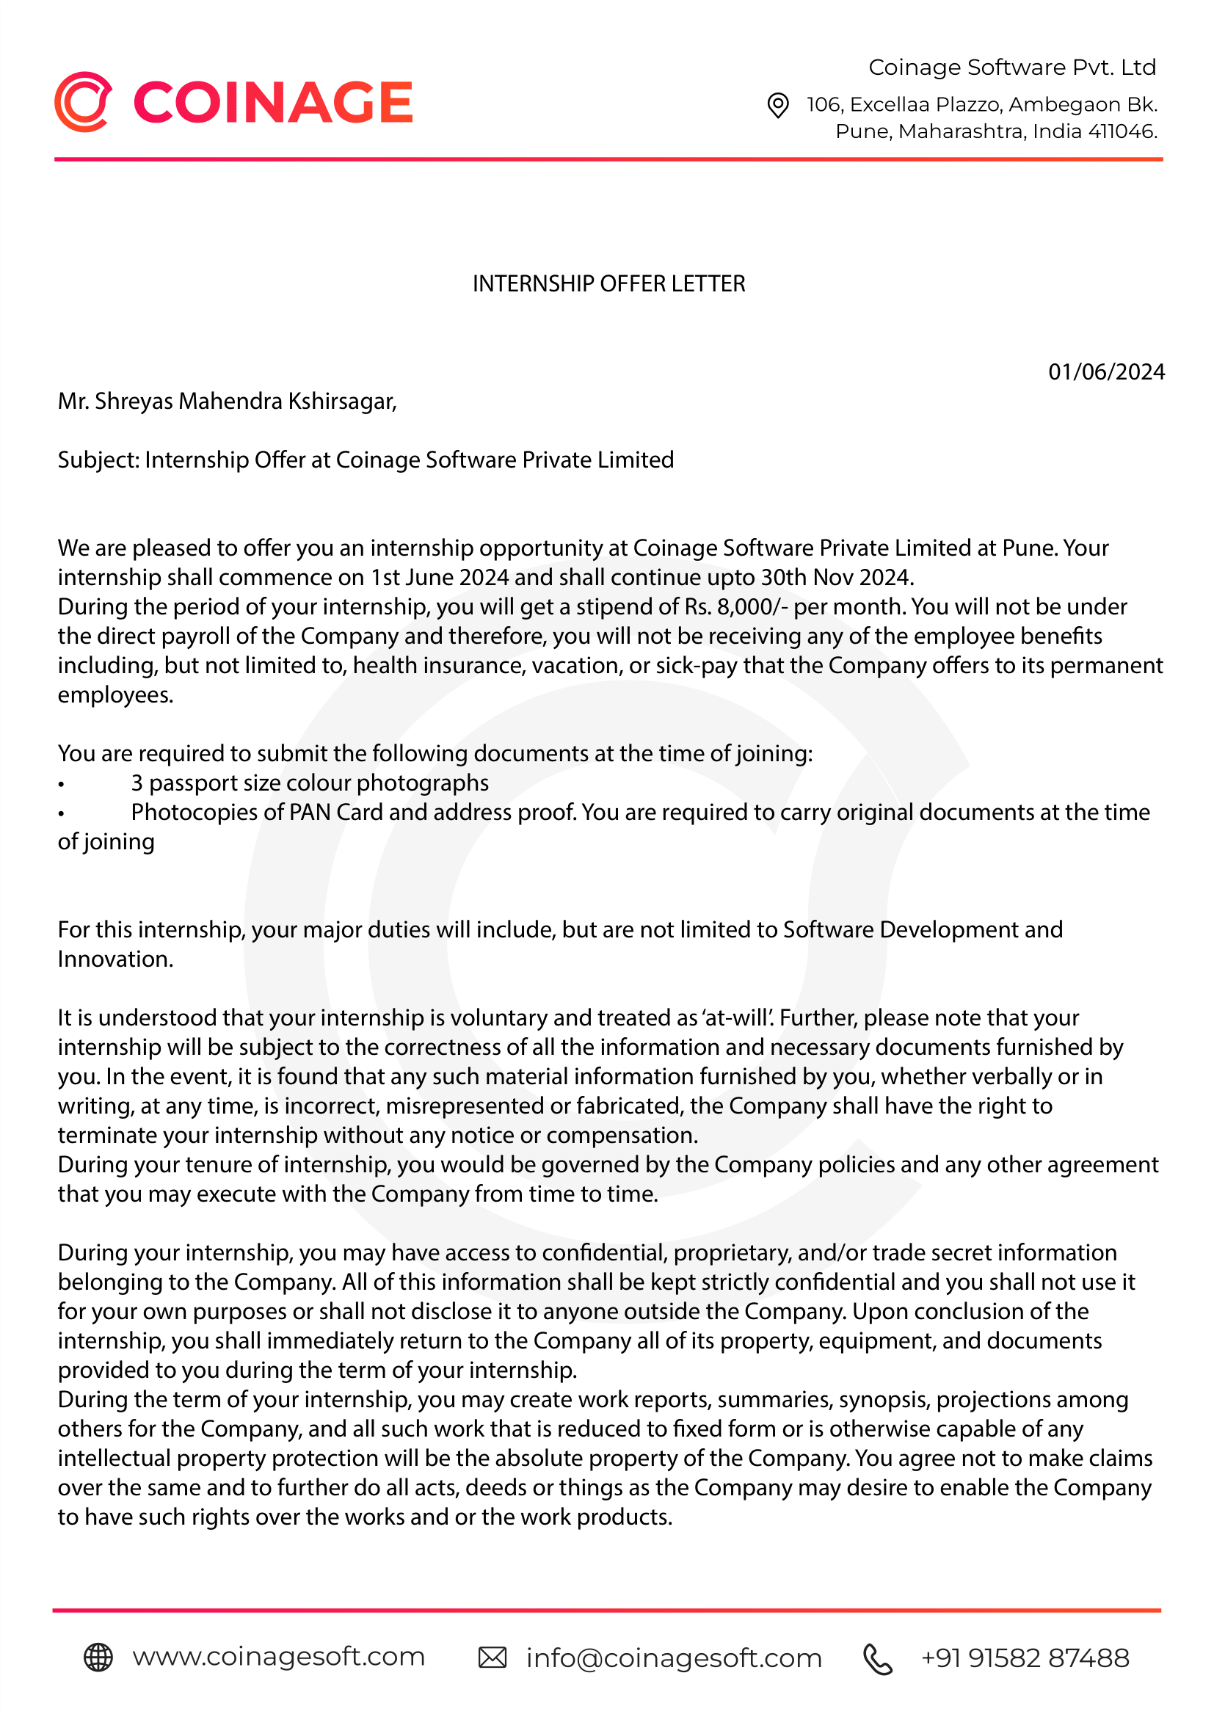

**Snapshot 8.3**: Six Month Offer Letter

### Industry Feedback

**Snapshot 8.4**: Industry Feedback

### Internship Poster

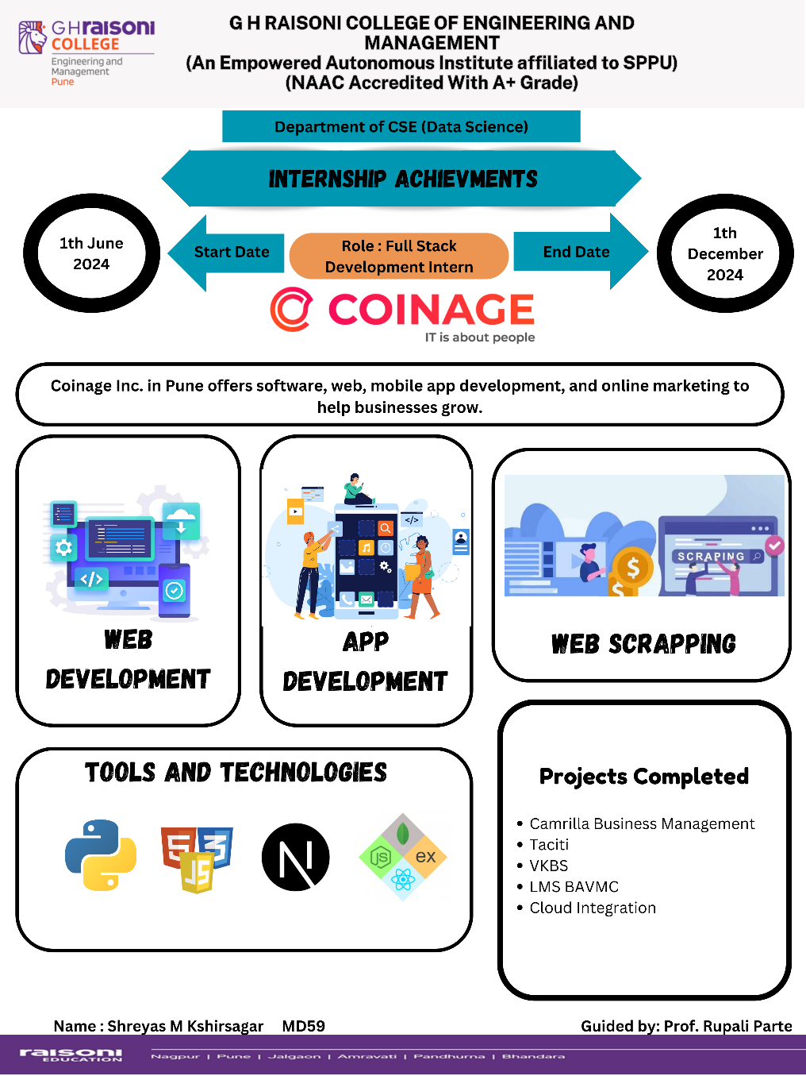

**Snapshot 8.5**: Poster Presentation

# CHAPTER 9

# CONCLUSION

### 9.1 Conclusion

Over the course of the six-month internship at Coinage Software Pvt. Ltd., I gained valuable hands-on experience in full-stack development and cloud computing, contributing to projects that emphasized innovation, technical skill, and user-centric design. My involvement in enhancing the Camrilla web version, deploying the Taciti project on Microsoft Azure, and implementing a Learning Management System for medical education, among others, allowed me to refine my technical expertise, problem-solving abilities, and collaborative skills.

This internship provided a unique opportunity to apply theoretical knowledge to practical challenges, enhancing my understanding of industry practices and standards. Each task, whether it involved coding, optimizing performance, or planning new software features, was an essential step in my professional growth. I am confident that the skills and experiences acquired during this internship will serve as a strong foundation for my future career in data science and software development.

The guidance from my internal and external mentors was invaluable in navigating the complexities of the projects and ensuring successful outcomes. This internship was not only a significant academic milestone but also a transformative experience that prepared me for the dynamic demands of the tech industry.